A Bit of a Hic-cup!!!

Ok, so perhaps that headline is a bit of an understatement. To be more precise, at 10:00am on Tuesday 5th June I tripped and fell whilst running on the lawn in my garden and landed on my head and broke my neck.

I immediately lost any feeling in my arms and from mid-chest down. I was in a very serious situation. An ambulance arrived very quickly but laying there on the grass it seemed like an eternity. The ambulance crew were terrific and got me to Lister Hospital where x-rays and CT scans were done. These were copied to Addenbrooke Hospital’s Spinal Injury Team in Cambridge. I was transferred to Addenbrooke’s that evening via the slowest ‘blues and twos’ journey ever… they wanted the trip to be as smooth as possible.

I was put into head traction, which is quite a barbaric, albeit necessary, procedure. Firstly they shave you just above and in front of your ears – a very dodgy haircut that if punk was still in might have looked quite cool to some! Then a horseshoe shaped frame with two spiked screws is fitted over your head and the screws are tightened through your scalp and into both sides of your skull! Then they hang 15 lbs from it to stretch your neck!

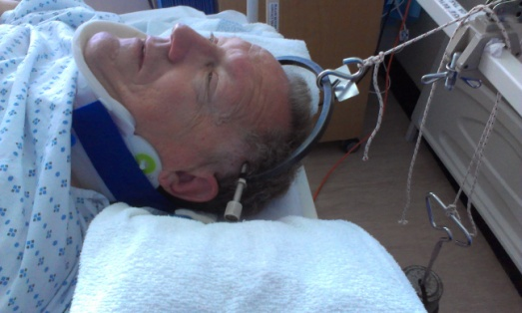

Regrettably all this did not achieve the desired effect so surgery was the last resort of action to give me any chance of getting me back on my feet. My C5/C6 vertebrae were still so out of line that a plate and four screws would be needed to be fitted to hold the two together in place. This was to be reinforced with a transplant of bone which was to be taken from my right hip. I do not have words sufficient to describe the skill and expertise with which this operation was undertaken by Mr Mannion and his team at Addenbrooke’s. I owe them so much! Below you can see the x-rays of my neck before and after the operation which was carried out early on Wednesday morning, 6th June.

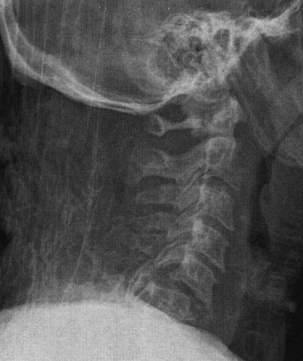
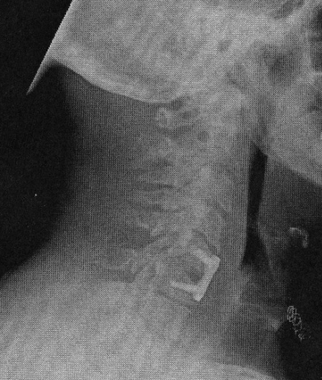

Shows displaced alignment of Shows how plate has brought
vertebrae before surgery vertebrae back into alignment

I currently have a weak grip in my left hand and the grip in my right hand is very feeble. There is pain in my left hand and my right forearm and hand. My left leg cannot register temperature. The staples in my hip and throat were removed today (Monday 11th June). However, there are so many positive things to be thankful for. With continued physiotherapy I should make a near 100% recovery. My sense of humour has remained intact and I am reassured that I have so many good friends who care for me

It’s now down to me to get my show back on the road! The Diamond Jubilee Swim from Teddington to Calais will have a new start date that will be announced in the near future.

WWW.TEDDINGTONTOCALAIS2012.ORG.UK

